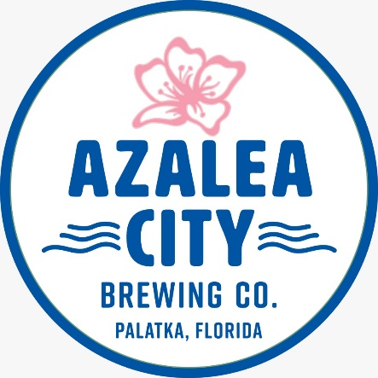
Coming in 2019 to the historic Coca-Cola building!
120 South 7th Street, Palatka
Get in on the ground floor with an annual membership!
Platinum Level – Lifetime benefits! All gold level features plus 50% discount on one event space rental and your name(s) on the taproom wall - $1,000
Gold level – 4 T-shirts/tanks, travel mug, four invitation-only VIP events and invitation to our Pre-Opening - $350
Silver Level – 2 T-shirts/tanks, travel mug, one invitation-only VIP event and invitation to our Pre-Opening - $150
Bronze Level – T-shirt/tank, travel mug and invitation to our Pre-Opening - $75
VIP events begin this summer. Pre-Opening is TBD.
Contact andrea@azaleacitybrewing.com or Facebook/Azalea City Brewing Company

